SOCIAL MEDIA ENGAGEMENT ANALYTICS

Project report

Submitted For: Data Analytics Internship
Submitted By: Subham
Company Name: Codec Technologies
Duration: Jan 2025 - Apr 2025

Abstract / Executive Summary
This report presents a comprehensive analysis of social media engagement across Facebook, Instagram, and LinkedIn from January to April 2025. Using a dataset of 2M impressions, the study evaluates content performance, platform effectiveness, and audience growth. Key findings show a 13% average engagement rate, with LinkedIn and Reels emerging as top performers. The insights aim to optimize future content strategy and improve ROI on social media marketing efforts.

Table of Contents
1. Introduction
2. Objective of the Study
3. Tools and Technologies Used
4. Methodology
5. Data Analysis and Key Findings
6. Conclusion
7. Recommendations

Introduction
Social Media Analytics involves collecting and analyzing data from social platforms to understand audience behavior and content performance. In today's digital era, engagement metrics directly impact brand visibility, customer loyalty, and revenue. This project focuses on analyzing engagement data to identify trends, evaluate content strategy, and provide data-driven recommendations.

Objective of the Study
1. To measure overall social media performance using key metrics like Likes, Comments, Shares, and Engagement Rate
2. To compare platform-wise effectiveness among Facebook, Instagram, and LinkedIn
3. To identify the best performing content type: Post, Reel, Story, or Carousel
4. To analyze follower growth trends and impressions vs likes correlation
5. To provide actionable recommendations for improving engagement

Tools and Technologies Used
- Power BI: For dashboard creation and data visualization
- Microsoft Excel: For initial data cleaning and preprocessing
- Meta Business Suite & LinkedIn Analytics: For data extraction
- Microsoft Word / Google Docs: For report documentation

Methodology
The project followed the CRISP-DM framework:
1. Data Collection: Exported 4 months of data from LinkedIn Analytics
2. Data Cleaning: Removed duplicates, null values, and spam comments using Excel
3. Data Transformation: Aggregated metrics by platform, content type, and month
4. Data Visualization: Built an interactive dashboard in Power BI to track KPIs
5. Analysis: Interpreted trends from charts and derived business insights

Data Analysis and Key Findings
Based on the Social Media Engagement Analytics Dashboard:
Overall KPIs
- Total Likes: 148K indicates strong content appeal
- Total Comments: 15K shows active two-way communication
- Total Shares: 10K reflects high content shareability
- Total Impressions: 2M signifies excellent brand visibility
- Average Engagement Rate: 13% is significantly above the industry average of 1-3%

Chart-wise Insights
1. Follower Growth: Followers increased from 12K in Jan 2025 to over 15K in Apr 2025, showing a consistent 25% growth in 4 months
2. Platform-wise Engagement: LinkedIn generated the highest likes, followed by Instagram and Facebook. This suggests professional content resonates most with the audience
3. Content Type Performance: Reels accounted for 28.83% of total engagement with 43K likes, making it the top-performing format. Posts 25.39%, Stories 23.3%, and Carousels 22.3% followed
4. Impressions vs Likes Analysis: The scatter plot shows a strong positive correlation. Higher impressions consistently resulted in higher likes, indicating good content quality
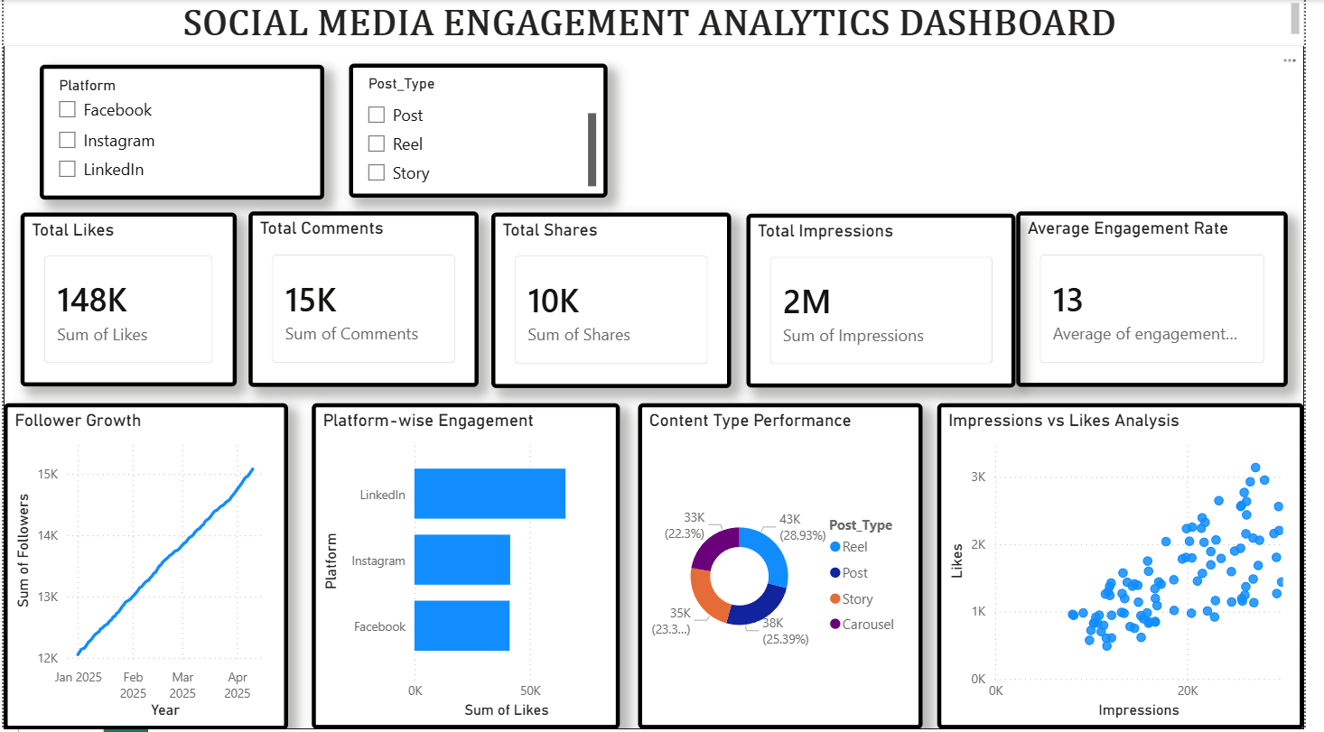

Conclusion
The analysis concludes that the current social media strategy is performing exceptionally well with a 13% engagement rate. Video-first content, especially Reels, and a strong presence on LinkedIn are the primary growth drivers. The positive follower growth trend and impressions-likes correlation confirm that the content is reaching the right audience.

Recommendations
1. Double down on Reels: Allocate 60% of content calendar to short-form video as it delivers the highest ROI
2. Leverage LinkedIn Strategy: Replicate LinkedIn's content style for other platforms to test performance
3. Optimize Carousels: Since Carousels had the lowest engagement at 22.3%, A/B test new designs and CTAs
4. Post Timing: Use insights from impressions data to schedule posts during peak activity hours

